MYSQL QUERIES

**COFFEE SHOP SALES PROJECT**

**1.CONVERT DATE (Transaction_Date) COLUMN TO PROPER DATE FORMAT**

UPDATE Coffee_Shop_Sales

SET Transaction_Date = STR_TO_DATE (Transaction_Date, '%D-%M-%Y');

**2.ALTER DATE (Transaction_Date) COLUMN TO DATE DATA TYPE**

ALTER TABLE Coffee_Shop_Sales

MODIFY COLUMN Transaction_Date DATE;

**3. CONVERT TIME (Transaction_Time) COLUMN TO PROPER DATE FORMAT**

UPDATE Coffee_Shop_Sales

SET Transaction_Time = STR_TO_DATE (Transaction_Time, '%H:%I:%S');

**4. ALTER TIME (Transaction_Time) COLUMN TO DATE DATA TYPE**

ALTER TABLE Coffee_Shop_Sales

MODIFY COLUMN Transaction_Time TIME;

**5. DATA TYPES OF DIFFERENT COLUMNS**

DESCRIBE Coffee_Shop_Sales;

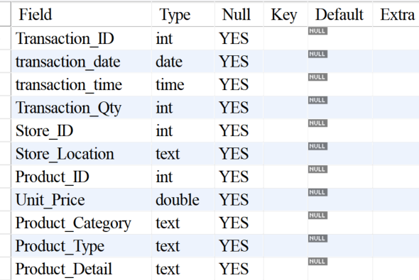

**6. CHANGE COLUMN NAME `Ï»¿Transaction_Id` To Transaction_Id**

ALTER TABLE Coffee_Shop_Sales

CHANGE COLUMN `Ï»¿Transaction_Id` Transaction_Id INT;

**7. Total Sales**

SELECT ROUND(SUM(Unit_Price * Transaction_Qty)) AS Total_Sales

FROM

Coffee_Shop_Sales

WHERE

MONTH(Transaction_Date) = 5; (5 Refers To May Month).

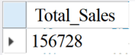

**8.TOTAL SALES KPI - MOM DIFFERENCE AND MOM GROWTH**

SELECT

MONTH(Transaction_Date) AS Month,

ROUND(SUM(Unit_Price * Transaction_Qty)) AS Total_Sales,

(SUM(Unit_Price * Transaction_Qty) - LAG(SUM(Unit_Price * Transaction_Qty), 1)

OVER (ORDER BY MONTH(Transaction_Date))) / LAG(SUM(Unit_Price * Transaction_Qty), 1)

OVER (ORDER BY MONTH(Transaction_Date)) * 100 AS MOM_Increase_Percentage

FROM

Coffee_Shop_Sales

WHERE

MONTH(Transaction_Date) IN (4, 5) -- For Months Of April And May

GROUP BY

MONTH(Transaction_Date)

ORDER BY

MONTH(Transaction_Date);

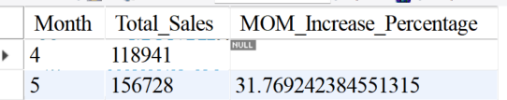

**9. Total Orders**

SELECT COUNT(Transaction_ID) AS Total_Orders

FROM

Coffee_Shop_Sales

WHERE

MONTH(Transaction_Date) = 3;

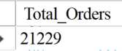

**10.TOTAL ORDERS KPI - MOM DIFFERENCE AND MOM GROWTH**

Select

Month(Transaction_Date)As Month,

Round(Count(Transaction_Id))As Total_Orders,

(Count(Transaction_Id)-Lag(Count(Transaction_Id),1)

Over(Order By Month(Transaction_Date)))/Lag(Count(Transaction_Id),1)

Over(Order By Month(Transaction_Date))*100 As MOM_Increase_Percentage

From

Coffee_Shop_Sales

Where

Month(Transaction_Date) In (4, 5) -- 4-April Month(Previous Month), 5-May Month Month(Current Month)

Group By

Month(Transaction_Date);

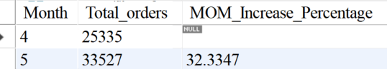

**11. Total Quantity Sold.**

SELECT SUM(Transaction_Qty)As Total_Quantity_Sold

FROM

Coffee_Shop_Sales

WHERE

MONTH(Transaction_Date) = 6;

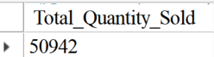

**12. TOTAL QUANTITY SOLD KPI - MOM DIFFERENCE AND MOM GROWTH**

Select

Month(Transaction_Date)As Month,

Sum(Transaction_Qty) As Total_Quantity_Sold,

(Sum(Transaction_Qty)-Lag(Sum(Transaction_Qty),1)

Over (Order By Month(Transaction_Date)))/Lag(Sum(Transaction_Qty),1)

Over (Order By Month(Transaction_Date))* 100 As MOM_Increase_Percentage

From Coffee_Shop_Sales

Where

Month(Transaction_Date) In (4,5) -- 4-April Month(Previous Month), 5-May Month Month(Current Month)

Group By Month(Transaction_Date)

Order By Month(Transaction_Date);

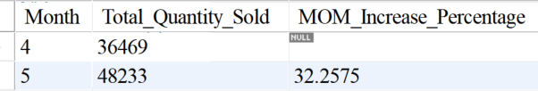

**13. CALENDAR TABLE – DAILY SALES, QUANTITY And TOTAL ORDERS**

SELECT

Concat(Round(SUM(Unit_Price * Transaction_Qty)/1000,1),'K') AS Total_Sales,

Concat(Round(Count(Transaction_Id)/1000,1),'K')As Total_Orders,

Concat(Round(Sum(Transaction_Qty)/1000,1),'K')As Toatl_QTY_Sold

FROM

Coffee_Shop_Sales

Where

Transaction_Date='2023-05-18';

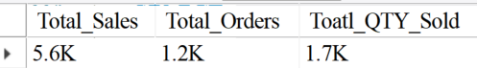

**14. SALES TREND OVER PERIOD (SALES TREND OVER PERIOD)**

SELECT

CONCAT(ROUND(AVG(Total_Sales) / 1000, 1), 'K') AS Avg_Sales

FROM

(

SELECT

SUM(Unit_Price * Transaction_Qty) AS Total_Sales

FROM

Coffee_Shop_Sales

WHERE

MONTH(Transaction_Date) = 5

GROUP BY Transaction_Date) AS Inner_Query;

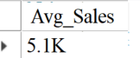

**15. DAILY SALES FOR MONTH SELECTED**

SELECT

DAY(Transaction_Date) AS Day_Of_Month,

ROUND(SUM(Unit_Price * Transaction_Qty),1) AS Total_Sales

FROM

Coffee_Shop_Sales

WHERE

MONTH(Transaction_Date) = 5 -- Filter For May

GROUP BY

DAY(Transaction_Date)

ORDER BY

DAY(Transaction_Date);

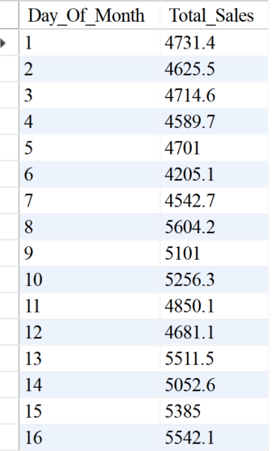 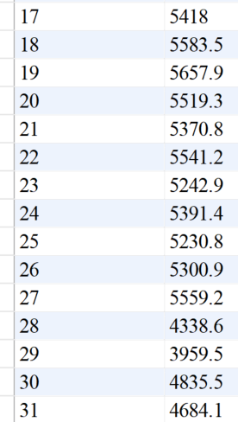

**16. COMPARING DAILY SALES WITH AVERAGE SALES – IF GREATER THAN “ABOVE AVERAGE” And LESSER THAN “BELOW AVERAGE”**

SELECT

Day_Of_Month,

CASE

WHEN Total_Sales > Avg_Sales THEN 'Above Average'

WHEN Total_Sales < Avg_Sales THEN 'Below Average'

ELSE 'Average'

END AS Sales_Status,

Total_Sales

FROM (

SELECT

DAY(Transaction_Date) AS Day_Of_Month,

Round(SUM(Unit_Price * Transaction_Qty),2) AS Total_Sales,

AVG(SUM(Unit_Price * Transaction_Qty)) OVER () AS Avg_Sales

FROM

Coffee_Shop_Sales

WHERE

MONTH(Transaction_Date) = 5 -- Filter For May

GROUP BY

DAY(Transaction_Date)

) AS Sales_Data

ORDER BY

Day_Of_Month;

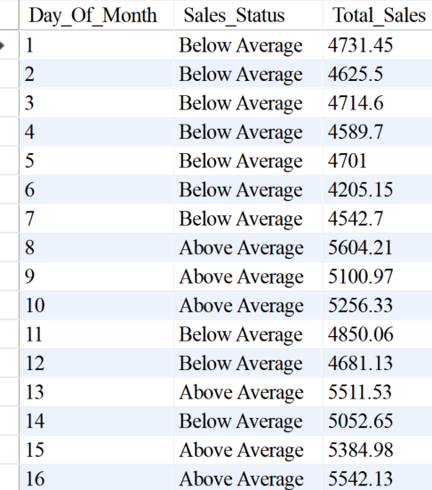 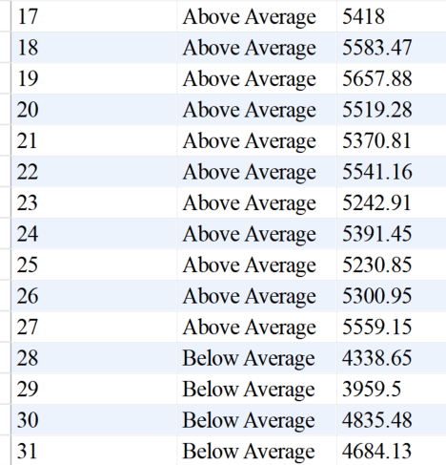

**17. Sales Analysis For Weekends And Weekdays**

SELECT

CASE

WHEN DAYOFWEEK(Transaction_Date) IN (1 , 7) THEN 'Weekends'

ELSE 'Weekdays'

END AS Day_Type,

CONCAT(ROUND(SUM(Unit_Price * Transaction_Qty) / 1000,1), 'K') AS Total_Sales

FROM

Coffee_Shop_Sales

WHERE

MONTH(Transaction_Date) = 5

GROUP BY CASE

WHEN DAYOFWEEK(Transaction_Date) IN (1 , 7) THEN 'Weekends'

ELSE 'Weekdays'

END

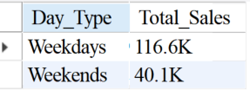

**18. Sales Analysis By Store Location.**

SELECT

Store_Location,

CONCAT(ROUND(SUM(Unit_Price * Transaction_Qty) / 1000,1),'K') AS Total_Sales

FROM

Coffee_Shop_Sales

WHERE

MONTH(Transaction_Date) = 5

GROUP BY Store_Location

ORDER BY Total_Sales

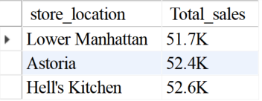

**19. Sales Analysis By Product Category.**

SELECT

Product_Category,

Round(SUM(Unit_Price * Transaction_Qty),1) AS Total_Sales

FROM

Coffee_Shop_Sales

WHERE

MONTH(Transaction_Date) = 5

GROUP BY Product_Category

Order By Total_Sales Desc;

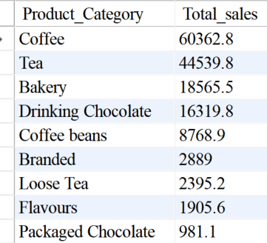

**20.Top 10 Products By Sales.**

SELECT

Product_Type,

Round(SUM(Unit_Price * Transaction_Qty),1) AS Total_Sales

FROM

Coffee_Shop_Sales

WHERE

MONTH(Transaction_Date) = 5

GROUP BY Product_Type

ORDER BY Total_Sales DESC

LIMIT 10;

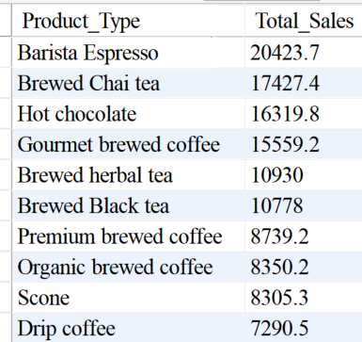

**21. Sales Analysis By Days And Hours**

SELECT

Round(SUM(Unit_Price * Transaction_Qty)) AS Total_Sales,

SUM(Transaction_Qty) AS Total_QTY_Sold,

COUNT(*) AS Total_Orders

FROM

Coffee_Shop_Sales

WHERE

MONTH(Transaction_Date) = 5

AND DAYOFWEEK(Transaction_Date) = 3

AND HOUR(Transaction_Time) = 8; -- Hour No 8

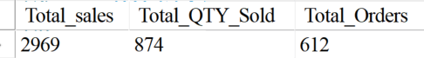

**22. TO GET SALES FROM MONDAY TO SUNDAY FOR MONTH OF MAY**

Select

Case

When Dayofweek(Transaction_Date) = 2 Then 'Monday'

When Dayofweek(Transaction_Date) = 3 Then 'Tuesday'

When Dayofweek(Transaction_Date) = 4 Then 'Wednesday'

When Dayofweek(Transaction_Date) = 5 Then 'Thursday'

When Dayofweek(Transaction_Date) = 6 Then 'Fridayday'

When Dayofweek(Transaction_Date) = 7 Then 'Saturday'

When Dayofweek(Transaction_Date) = 1 Then 'Sunday'

End As Day_Of_Week,

Round(Sum(Unit_Price*Transaction_Qty))As Total_Sales

From

Coffee_Shop_Sales

Where

Month(Transaction_Date)=5

Group By

Case

When Dayofweek(Transaction_Date) = 2 Then 'Monday'

When Dayofweek(Transaction_Date) = 3 Then 'Tuesday'

When Dayofweek(Transaction_Date) = 4 Then 'Wednesday'

When Dayofweek(Transaction_Date) = 5 Then 'Thursday'

When Dayofweek(Transaction_Date) = 6 Then 'Fridayday'

When Dayofweek(Transaction_Date) = 7 Then 'Saturday'

When Dayofweek(Transaction_Date) = 1 Then 'Sunday'

End;

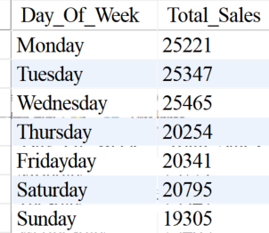

**23.TO GET SALES FOR ALL HOURS FOR MONTH OF MAY**

Select

Hour(Transaction_Time)As Hours,

Round(Sum(Unit_Price*Transaction_Qty))As Total_Sales

From

Coffee_Shop_Sales

Where

Month(Transaction_Date)=5

Group By

Hours

Order By

Hours;

